**Homework 4 Solution**

1. Find two other famous number theory conjectures. Briefly describe what the conjecture says and add any information about the current status of the work on this conjecture.

I will cheat and list some online sources that have excellent information. Some of the pages have non-number theory conjectures too, but it’s still useful information.

<https://link.springer.com/content/pdf/bbm%3A978-1-4614-6636-9%2F1.pdf>

<https://mathworld.wolfram.com/UnsolvedProblems.html>

<https://www.popularmechanics.com/science/math/g29251596/impossible-math-problems/>

<https://primes.utm.edu/notes/conjectures/>

The following is not a list but talks about one conjecture. I include it because it’s a current famous number theory conjecture and it was excluded from the previous lists:

<https://dash.harvard.edu/bitstream/handle/1/2793857/Elkies%20-%20ABCs%20of%20Number%20Theory.pdf>

The following one doesn’t quite fit the category asked, but it’s useful for professors:  
<https://mathoverflow.net/questions/100265/not-especially-famous-long-open-problems-which-anyone-can-understand>

My own favorite number theory conjectures are:  
Riemann hypothesis; Collatz conjecture; Mersenne primes; odd perfect prime conjecture; e+pi rational?; Euler-Macheroni constant.

Two of [Landau's Problems](https://en.wikipedia.org/wiki/Landau%27s_problems) (quotes taken from the wikipedia page):

* Does there always exist a prime number between consecutive square numbers?
  + "the conjecture holds to $4⋅10^{18}$. A counterexample near $10^{18}$ would require a prime gap fifty million times the size of the average gap."
  + "A result due to Ingham shows that there is a prime between $n^{3}$ and $(n+1)^{3}$ for every large enough $n$."
* Are there infinitely many prime numbers of the form $n^{2}+1$?
  + "Henryk Iwaniec showed that there are infinitely many numbers of the form $n^{2}+1$ with at most two prime factors"
  + "Merikoski ... showed that there are infinitely many numbers of the form $n^{2}+1$ with greatest prime factor at least $n^{1.279}$. Replacing the exponent with 2 would yield Landau's conjecture."

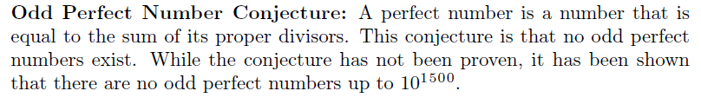

* Collatz Conjecture: This conjecture states that if we start with any positive integer *n*, we can create a sequence using the rules that if *n* is even divide it by 2, and if *n* is odd plug it into the function 3*n*+1[.](https://docs.google.com/document/d/1bK4hRmifCHVCynyag6JvIicP_G4DhDs1eJL5Hzr0zqU/edit?ts=5f0b8075#D2L_inline_eq_$3n+1$) The conjecture states that this sequence will always end at 1. Although the conjecture has not been proven, many mathematicians believe the conjecture to be true based on experimental evidence. At this point up to ${2,}^{68 }$ integers have been tested to see if the conjecture holds. The only way that the conjecture can be proven false is if a sequence that does not contain 1 is found, this sequence would by a cycling sequence, or if the sequence increases without bound, neither of these have been found to occur.
* Legendre’s Conjecture: This conjecture states that there is a prime number between $n^{2}$ and [for every positive in](https://docs.google.com/document/d/1bK4hRmifCHVCynyag6JvIicP_G4DhDs1eJL5Hzr0zqU/edit?ts=5f0b8075#D2L_inline_eq_$(n+1)%5E2$)teger [.](https://docs.google.com/document/d/1bK4hRmifCHVCynyag6JvIicP_G4DhDs1eJL5Hzr0zqU/edit?ts=5f0b8075#D2L_inline_eq_$n$) As of 2020 the conjecture has not been proven nor disproven. Ingham showed for sufficiently large *n* there is a prime between consecutive cubes. A table of prime gaps shows that this conjecture holds up to $n=2⋅10^{9}$. But these are only partial results to help prove the conjecture.

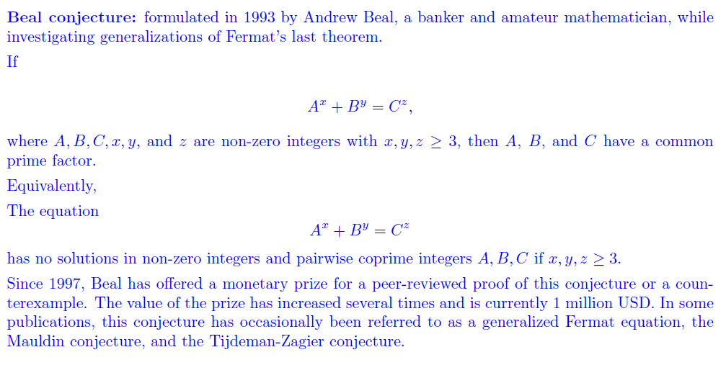

1. Find the prime factorization of 185803 by hand. (Briefly explain your method for finding the prime factorization.)

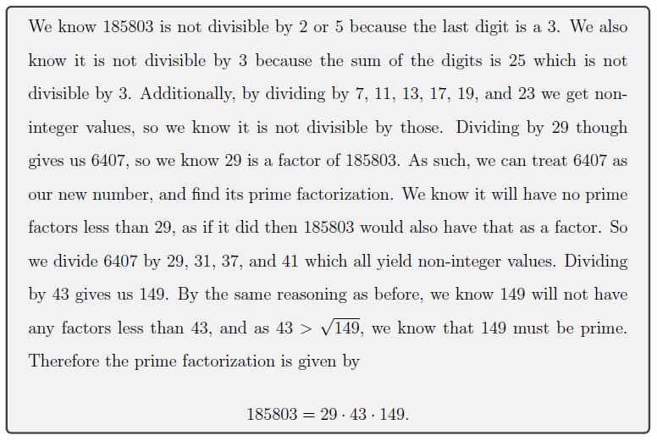

1. Show that there are infinitely many prime numbers of the form $3n+2.$ (The same idea applies for prime numbers of the form $6n+5.$)

Five is a prime number of the form $3n+2$ so we know there exists at least one. Assume there are finitely many primes $p_{1}, p_{2}, ..., p_{r}$ of the form $3n+2$. Consider $k=3p_{1}p_{2}...p_{r}-1$. We know $k≡-1 (mod p_{i})$ for each $1≤i≤r$ so no $p_{i}$ divides $k$. Three also does not divide $k$ so each prime factor of $k$ must have a remainder of 1 modulo 3. But the product of numbers of the form $3m+1$ will have a remainder of 1. We know that $k≡2 (mod 3)$ so we have reached a contradiction.

Suppose there are finitely many primes ${2, p}_{1}, p_{2}, ..., p_{k}$ of the form $3n+2.$ Let $N={3p}_{1}p_{2}⋅⋅⋅p_{k}+2.$ If $N$ is prime, we have a contradiction because it is of the form $3n+2$ and is larger than all $p_{i},$ which are all possible primes of the form $3n+2.$ If $p_{i}$ divides $N,$ then $p_{i} | 2,$ which is a contradiction. So no $p_{i}$ divides $N.$ Since all $p_{i}$ are odd, $N$ is odd and hence 2 does not divide $N$ either. Therefore, all factors of $N$ must be of the form $3n+1.$ But this means that the product of all those factors mod 3 is equal to 1, and hence $N$ must be congruent to 1 mod 3 as well, which is another contradiction. Since we reached a contradiction in all possible cases, that means there are infinitely many primes of the form $3n+2.$

Let’s assume that there are finitely many 6n+5 primes and show a contradiction.

Say there are k prime numbers of the form 6n+5 and consider 6*(p1*p2*...*pk) - 1. Notice that our number is of the form 6n+5. By our assumption there were only k primes of this form so our number must be composite. Notice that our number is 1 down from a multiple of every 6n+5 prime. This means that it is not divisible by these primes. That means all of the factors of this number must be primes of the form 6n+1, as 6n+2, 6n+3,6n+4 are divided by 2 or 3. But if all the factors are 6n+1, there is no way to multiply them together to get a 6n+5 number, so our assumption must be wrong and there are infinitely many 6n+5 primes.

1. Show that the binomial coefficient [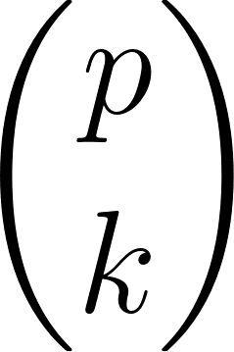](https://www.codecogs.com/eqnedit.php?latex=%5Cbinom%7Bp%7D%7Bk%7D#0) is divisible by *p* if *p* is prime and $1≤k<p.$

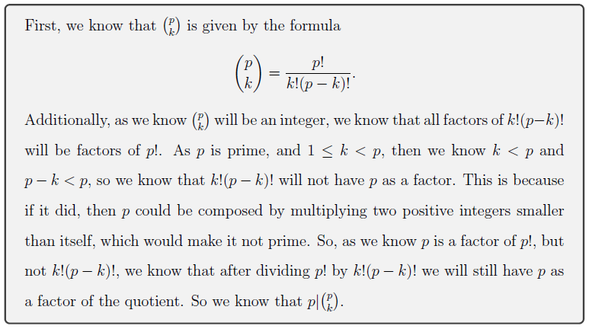

1. Let $p_{n}$ be the *n*th prime number.
2. Show that $p_{n}≤p_{1} p_{2} ⋅⋅⋅p_{n-1}+1.$

For each $i$ where $1≤i≤n-1$, we know $p_{1}p_{2}...p_{n-1}+1≡1 (mod p_{i})$ and so $p_{i}$ does not divide it. Thus, either $p_{1}p_{2}...p_{n-1}+1$ is a prime larger than $p_{n-1}$ or else each of its prime factors is larger than $p_{n-1}$ and less than $p_{1}p_{2}...p_{n-1}+1.$ Therefore, the next prime $p_{n}$ greater than $p_{n-1}$ satisfies $p_{n}≤p_{1} p_{2} ⋅⋅⋅p_{n-1}+1.$

1. Use part a. to show that $p_{n}<{2^{2}}^{n}.$ (Hint: Use induction.)

* I will inductively prove that $p_{n}≤2^{2^{n-1}}$ which implies $p_{n}<2^{2^{n}}$.
* Basis: $p_{1}≤2^{2^{0}}$ because $2≤2$.
* Strong Induction: Assume that $p_{i}≤2^{2^{i-1}}$ for all $1≤i≤k$ for some $k≥1$. Show that $p_{k+1}≤2^{2^{k}}$.
  + From part a we know that $p_{k+1}≤p_{1}p_{2}...p_{k}+1$. By assumption we know that $p_{i}<2^{2^{i-1}}$ for each $1≤i≤k$.
  + Combining these facts yields $p_{k+1}≤2^{2^{0}}2^{2^{1}}...2^{2^{k-1}}+1$.
  + Simplifying this yields $p_{k+1}≤2^{2^{k}-1}+1=2^{2^{k}}/2+1$.
  + The division by 2 reduces the expression's value by at least 1 since $2^{2^{k}}≥2$ for $k≥0$. Thus, removing the division by 2 as well as the plus 1 will either not change the expression's value at all or it will increase it. Mathematically, $2^{2^{k}}/2+1≤2^{2^{k}}$.
  + Thus, $p_{k+1}≤2^{2^{k}}$.
* We have thus inductively proven that $p_{n}≤2^{2^{n-1}}$ for $n≥1$. This then implies that $p_{n}<2^{2^{n}}$.

1. Write a code to implement the Eratosthenes Sieve to create the list of all primes up to *n* for given *n*.

I will cheat again. I had the idea in mind but couldn’t figure out how to code it properly. I was thinking of assigning 0/1 to each spot and then switching the number to 0 if it was a multiple, but my Python still isn’t that great. So here’s a pretty neat way of coding what I was trying to do with 0/1 idea:

<https://www.geeksforgeeks.org/python-program-for-sieve-of-eratosthenes/>